 | I. General project information
Project | Construction, maintenance and operation of selected sections of the D3 motorway and the R3 speedway.
Public authority | Ministry of Transport
Strategy | The project strategy is to improve the traffic serviceability of the South Bohemian region – link the city of Prague to the Tábor and České Budějovice area to the national network of motorways in the Czech Republic and Austria by means of the new D3 motorway.
Project aim | Provide for the construction, financing, maintenance and operation of a section of the D3 motorway and the R3 speedway using the PPP method.  To ensure the optimal form of financing providing the maximal savings on public resources.
Project description | This project comprises: (i) operation and maintenance of sections 0305/II to 0308/B (approx. 42.11km) and (ii) construction, maintenance and operation of sections 0308/C to 0312/II (approx. 71.4km). The length of the whole sections in the project is approx. 113.5km.  The proposed D3 route is a part of the main international road E55, which connects Scandinavia with Germany, the Czech Republic, Austria, Italy and Greece. The D3 motorway is also incorporated in the supplementary TINA network of key European traffic routes.  The planned length of the D3 motorway is 171.4km in total, of which 8.3km are already in full use, 17.7km are in limited use and 145.5km are being prepared for construction.
Status | The Outline Business Case was approved by Government Decree No. 1304 on 20 October 2008. This resolution also assigned the Minister of Transport to launch selective procedure and to inform the Government about its results.
Team of advisors | Legal advisors: Weil, Gotshal and Manges  Financial advisors: ING. Bank N.V., Facility s.r.o.
Capital value | The investment costs are estimated at about CZK 28.4 billion.
 | II. Envisaged characteristics of the PPP project
Note | The information contained below (*) is just a preliminary projection made by the Authority and shall not be in any case deemed as binding. The final information will be specified when the concession dialog on the Project Agreement is over.
PPP form* | DBOT (Design, Build, Operate, Transfer)
Contract duration* | The term of operation of the motorway by the concessionaire shall be 30 years from its setting into operation or from the assignment of each functional section.
Risk transfer* | The private partner will bear the key risks – construction, availability and service risks.
Payment mechanism* | Availability fee payment.
Project schedule* | ** A valid schedule containing the subsequent steps has not been approved yet.
  Year | 2007 |  |  |  | 2008 |  |  |  | 2009 |  |  |  | 2010 |  |  |  | 2011
  Activities/quarter | 1 | 2 | 3 | 4 | 1 | 2 | 3 | 4 | 1 | 2 | 3 | 4 | 1 | 2 | 3 | 4 | 1 | 2 | 3 | 4
  Preparation of Outline Business Case (OBC)
  OBC approval
  Selection of concessionaire
  Execution of project Agreement
  Construction commencement
  Operation commencement
Map | 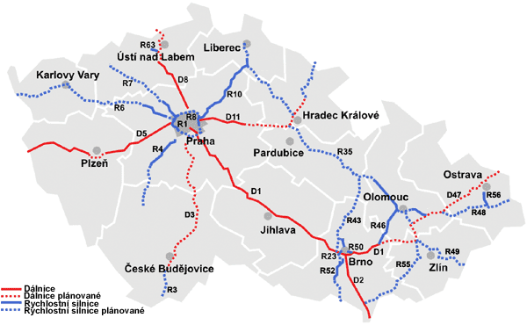
PPP Centrum  Czezg Republic | PPP Centrum is a center for PPP implementation in the Czech Republic; it is fully owned by the Czech Republic and reports to the Ministry of Finance.
Contact
  Ministry of Transport  Nábřeží Ludvíka Svobody 12, 110 15 Prague 1  Czech Republic  tel.: +420 225 131 111  email: webmd@mdcr.cz  web: www.mdcr.cz | PPP Centrum, a.s.  Jan Škurek  Chief Executive Officer  Na Příkopě 3, 110 00 Prague 1  Czech Republic  tel.: +420 22014 5350, fax: +420 22014 5351  mobile: +420 602 166 011  email: jan.skurek@pppcentrum.cz  web: www.pppcentrum.cz

