 | I. General project information
Project | Airport Connection (AirCon) – Upgrade of the Prague-Kladno railway line and construction of a railway connection to the Ruzyně Airport, including operation and maintenance. The project will be implemented as a PPP.
Public authority | The Ministry of Transport together with the Railway Infrastructure Administration (SZDC) – owner of railway infrastructure.  Other stakeholders: Prague City Hall, Central Bohemia Region, Prague 6 District, Prague 7 District, Prague 1 District, Czech Airport Administration, Czech Railways, municipalities: Hostivice and Jeneč.
Strategy | The project’s strategy is to (i) improve significantly the traffic serviceability of the Ruzyně Airport and the northwestern part of the Prague agglomeration, which is one of the most important dynamically developing regions, (ii) connect the Ruzyně Airport to the railway network and integrate the transport infrastructure in the northwestern part of the Prague agglomeration by creating a top-quality high-capacity railway line between Prague and Kladno.  At present, roads carry most of the traffic due to the insufficient parameters of the current railway connection. The significant traffic overload and the environmental burden are primarily caused by the citizens residing in the Kladno region, commuting to Prague every day. The continuous increase in the volume of road service associated with the increasing number of arrivals to and departures from the Ruzyně Airport makes this situation even worse.
Project aim | Provide a system of train connection with a fixed, easy-to-remember schedule that would offer a fast, comfortable and environmentally friendly connection between the center of Prague and the Ruzyně Airport.
Project description | Preparation for the construction (upgrade) of a fast railway line between the Prague Airport and the city center. The exact design with technical and economic details will be specified in Outline Business Case.
Status | The Outline Business Case is prepared now.  Several studies have been prepared:  - “Feasibility study of the upgrade of the Prague - Kladno railway section, including a new branch line to the Ruzyně Airport” (SUDOP Prague – December 2003),  - “Study of optimum project funding for the upgrade of the Prague – Kladno railway section, including a new branch line to the Ruzyně Airport” (ATKINS – March 2004),  - “Application of PPP in the financing of transport projects from EU funds, incl. AirCon case study” (Johnson & Kramařík – November 2005)  - “Comparison of AirCon project options” (PPP Centrum – June 2008).
Capital value | The projected investment costs are about CZK 20 billion.

 | II. Envisaged characteristics of the PPP project
Note | The information contained below (*) is just a preliminary projection made by the Authority and shall not be in any case deemed as binding. The final information will be specified in cooperation with the advisor.
PPP form* | BOT or DBFO – form of a long-term project agreement on the construction, operation and maintenance of the line and a project agreement on traffic operation, with the state’s financial participation of about 10%.
Contract duration* | A long-term agreement for 30 to 40 years is expected.
Risk transfer* | The private partner should bear all major risks, including construction risks and risks of infrastructure availability. The demand risk is envisaged to be shared with the Authority.
Payment mechanism* | Income from fares collected from the passengers, fees for infrastructure availability and payments for the use of the railway infrastructure should be key sources of income.
Project schedule* | ** A valid schedule containing the subsequent steps has not been approved yet.
  Year | 2008 |  |  |  | 2009 |  |  |  | 2010 |  |  |  | 2011 |  |  |  | 2012
  Activities / quarter | 1 | 2 | 3 | 4 | 1 | 2 | 3 | 4 | 1 | 2 | 3 | 4 | 1 | 2 | 3 | 4 | 1 | 2 | 3 | 4
  Preparation of Outline Business Case (OBC)
  OBC approval
  Selection of concessionaire
  Execution of Project Agreement
  Construction commencement
  Operation commencement
Map | 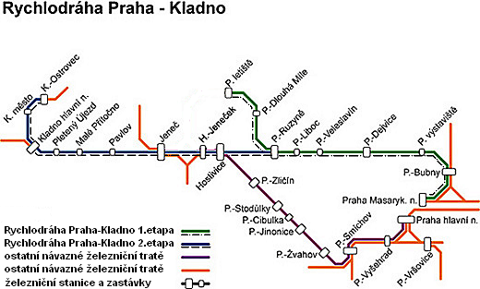
PPP Centrum  Czech Republic | PPP Centrum is a center for PPP implementation in the Czech Republic; it is fully owned by the Czech Republic and reports to the Ministry of Finance. PPP Centrum helps the Ministry of Transport with project preparation.
Contact
  Ministry of Transport  Bohumír Páleník  Project Manager  Nábřeží Ludvíka Svobody 12, 110 15 Prague 1  Czech Republic  tel.: +420 225 131 613, fax: ++420 225 131 677  mobile: +420 606 859 695  email: bohumir.palenik@mdcr.cz  web: www.mdcr.cz | PPP Centrum, a.s.  Jan Škurek  Chief Executive Officer  Na Příkopě 3, 110 00 Prague 1  Czech Republic  tel.: +420 22014 5350, fax: +420 22014 5351  mobile: +420 602 166 011  email: jan.skurek@pppcentrum.cz  web: www.pppcentrum.cz

